Food saver
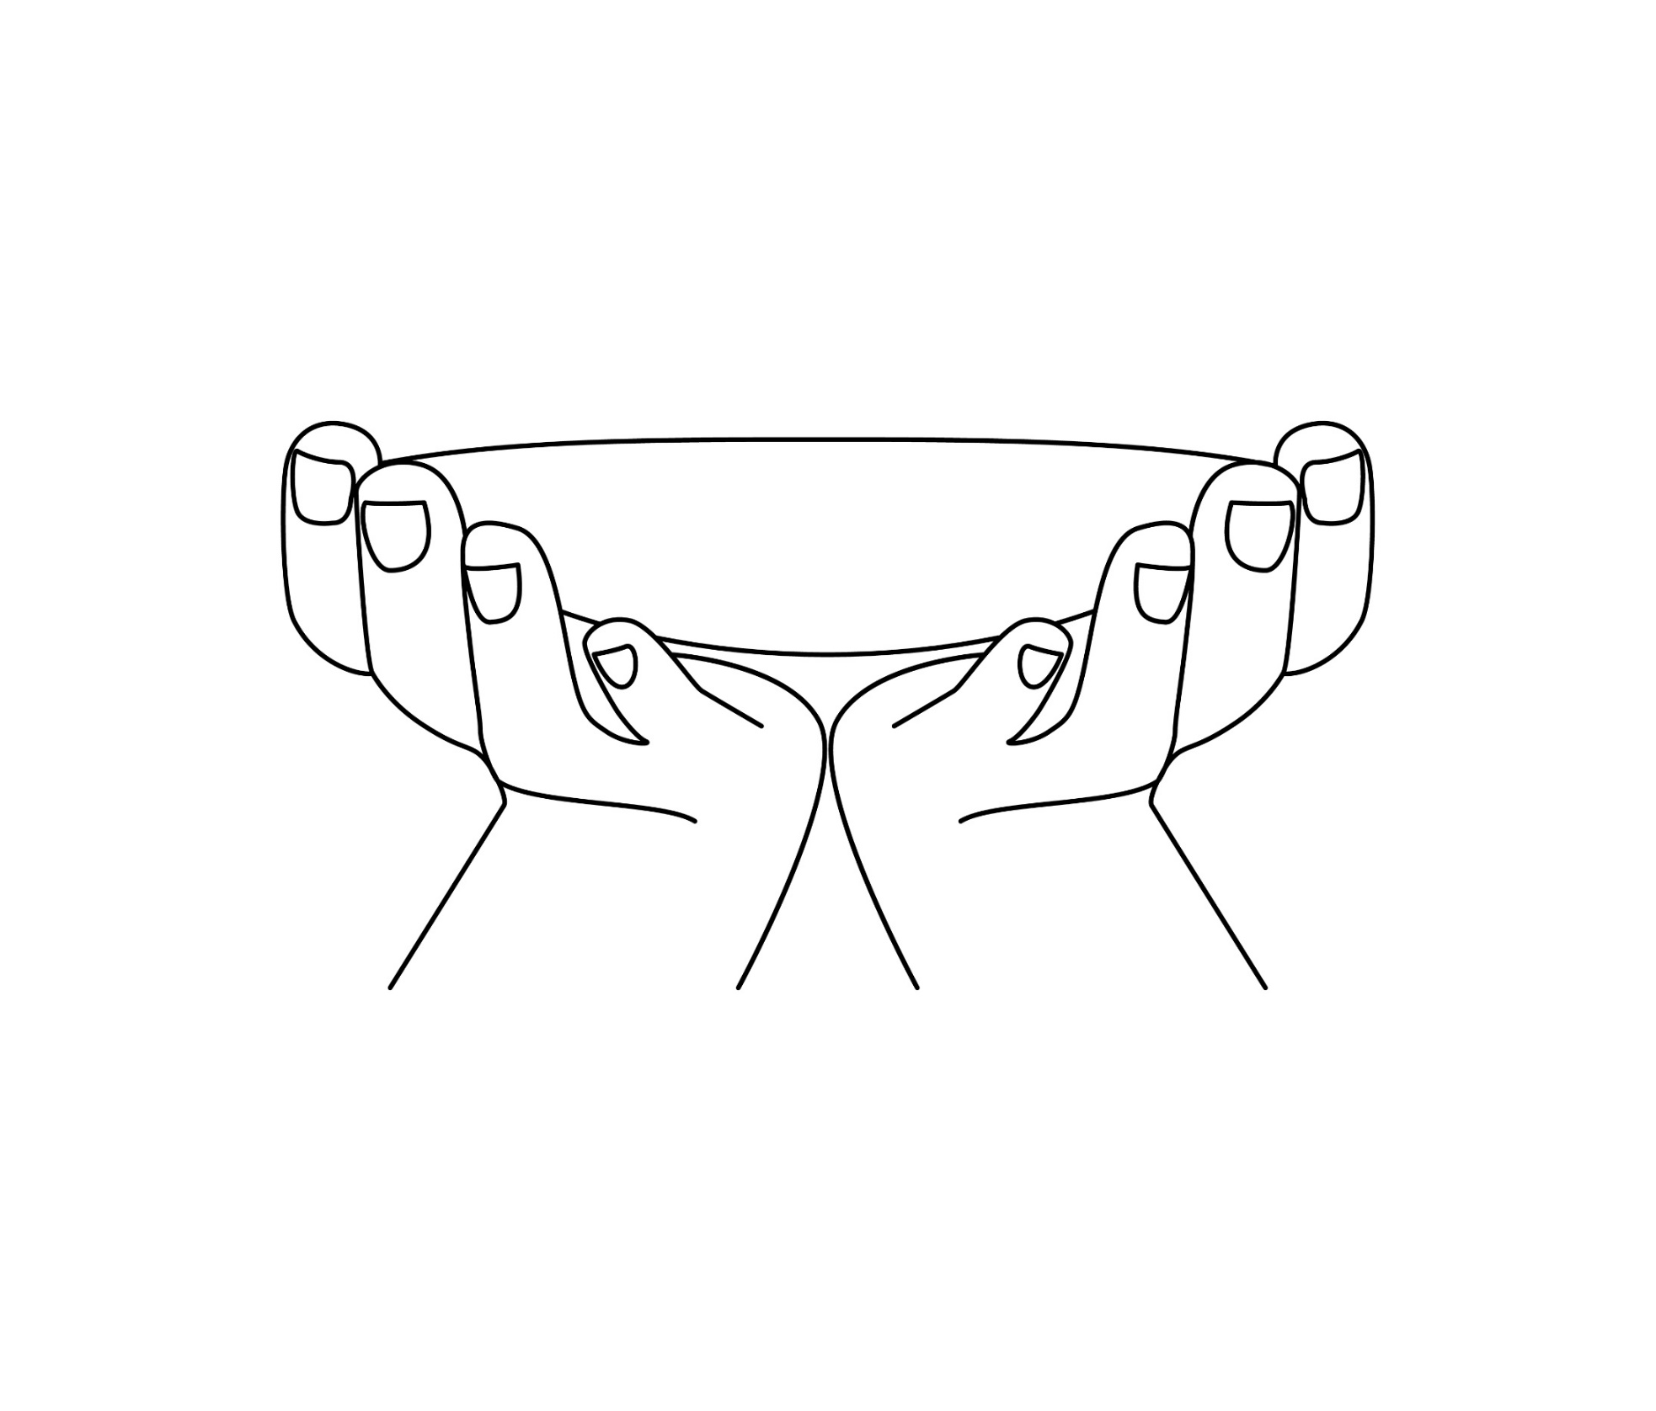
Add a green dot to the dish each time you save some food from being wasted.
Food that has been saved:

__________________________

__________________________

__________________________

__________________________

__________________________
__________________________

