Find the food and drinks activities

Print copies of the Find the food and drinks sheet. Gather some counters and colour pencils,
and try these activities with small groups of children.
Using counters  Bingo!  Give the children a Find the food and drinks sheet each, or one per pair. Call out the names of the foods on the sheet in a random order. As you call out each food, challenge the children to find that food on their sheet and cover it with a counter. Once the children have covered all the foods, they can shout, bingo! (They should finish at the same time!)  Cover up!  Read out the descriptions below and task the children to cover the foods that meet each description. They can take the counters off the food/s before each new description is read out.  Challenge the children to see if they can give some descriptions for foods that other children can try and find and cover! | Using coloured pencils  Challenge the children to:  - Put a tick by their three favourite foods.  - Put a question mark by any foods they haven’t tried before.  - Write the first letter of each food or drink next to its picture.  - Draw a circle around foods beginning with B.  - Draw a wavy line under any foods that are soft.  - Draw a leaf by any foods that come from plants.  Ask the children to set some similar challenges for each other.  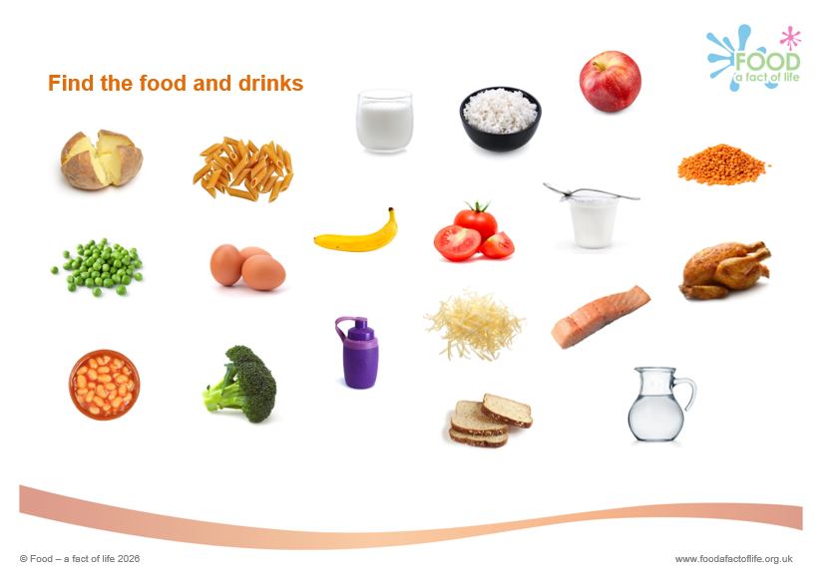
  Cover up: | Put a blue counter on the:
  - Orange foods  - Circular foods  - Piles of foods  - Vegetables  - Drinks  - Foods that come from animals | - Rice  - Eggs  - Tomatoes  - Bread  - Yogurt

