Farming our food
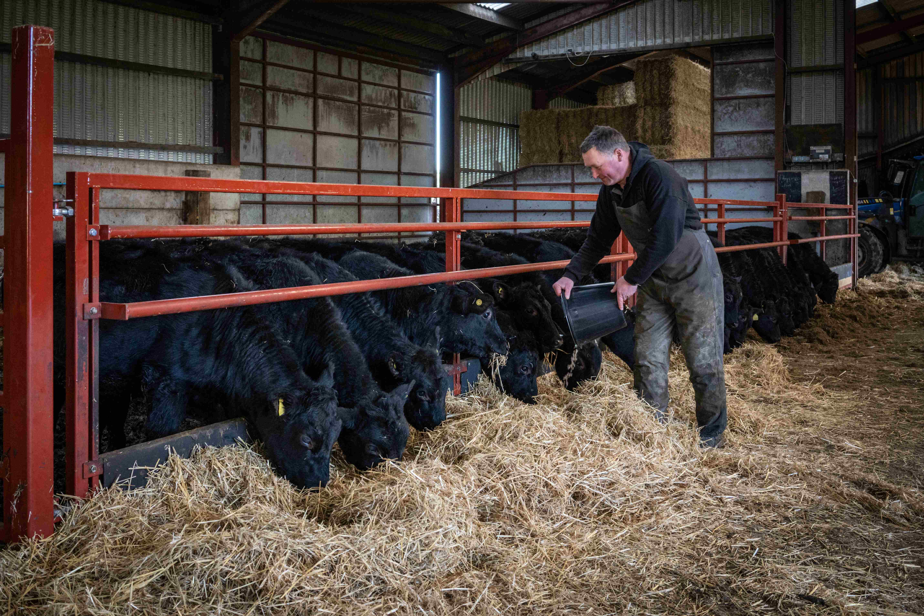
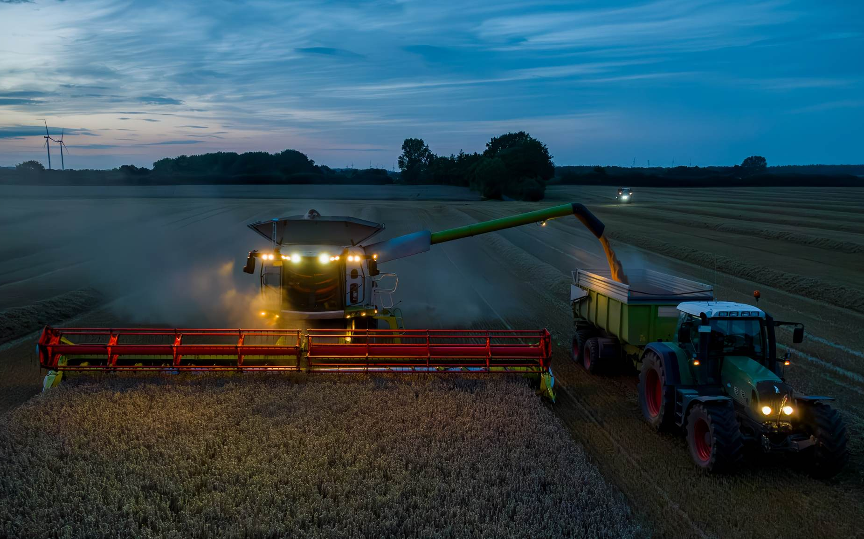
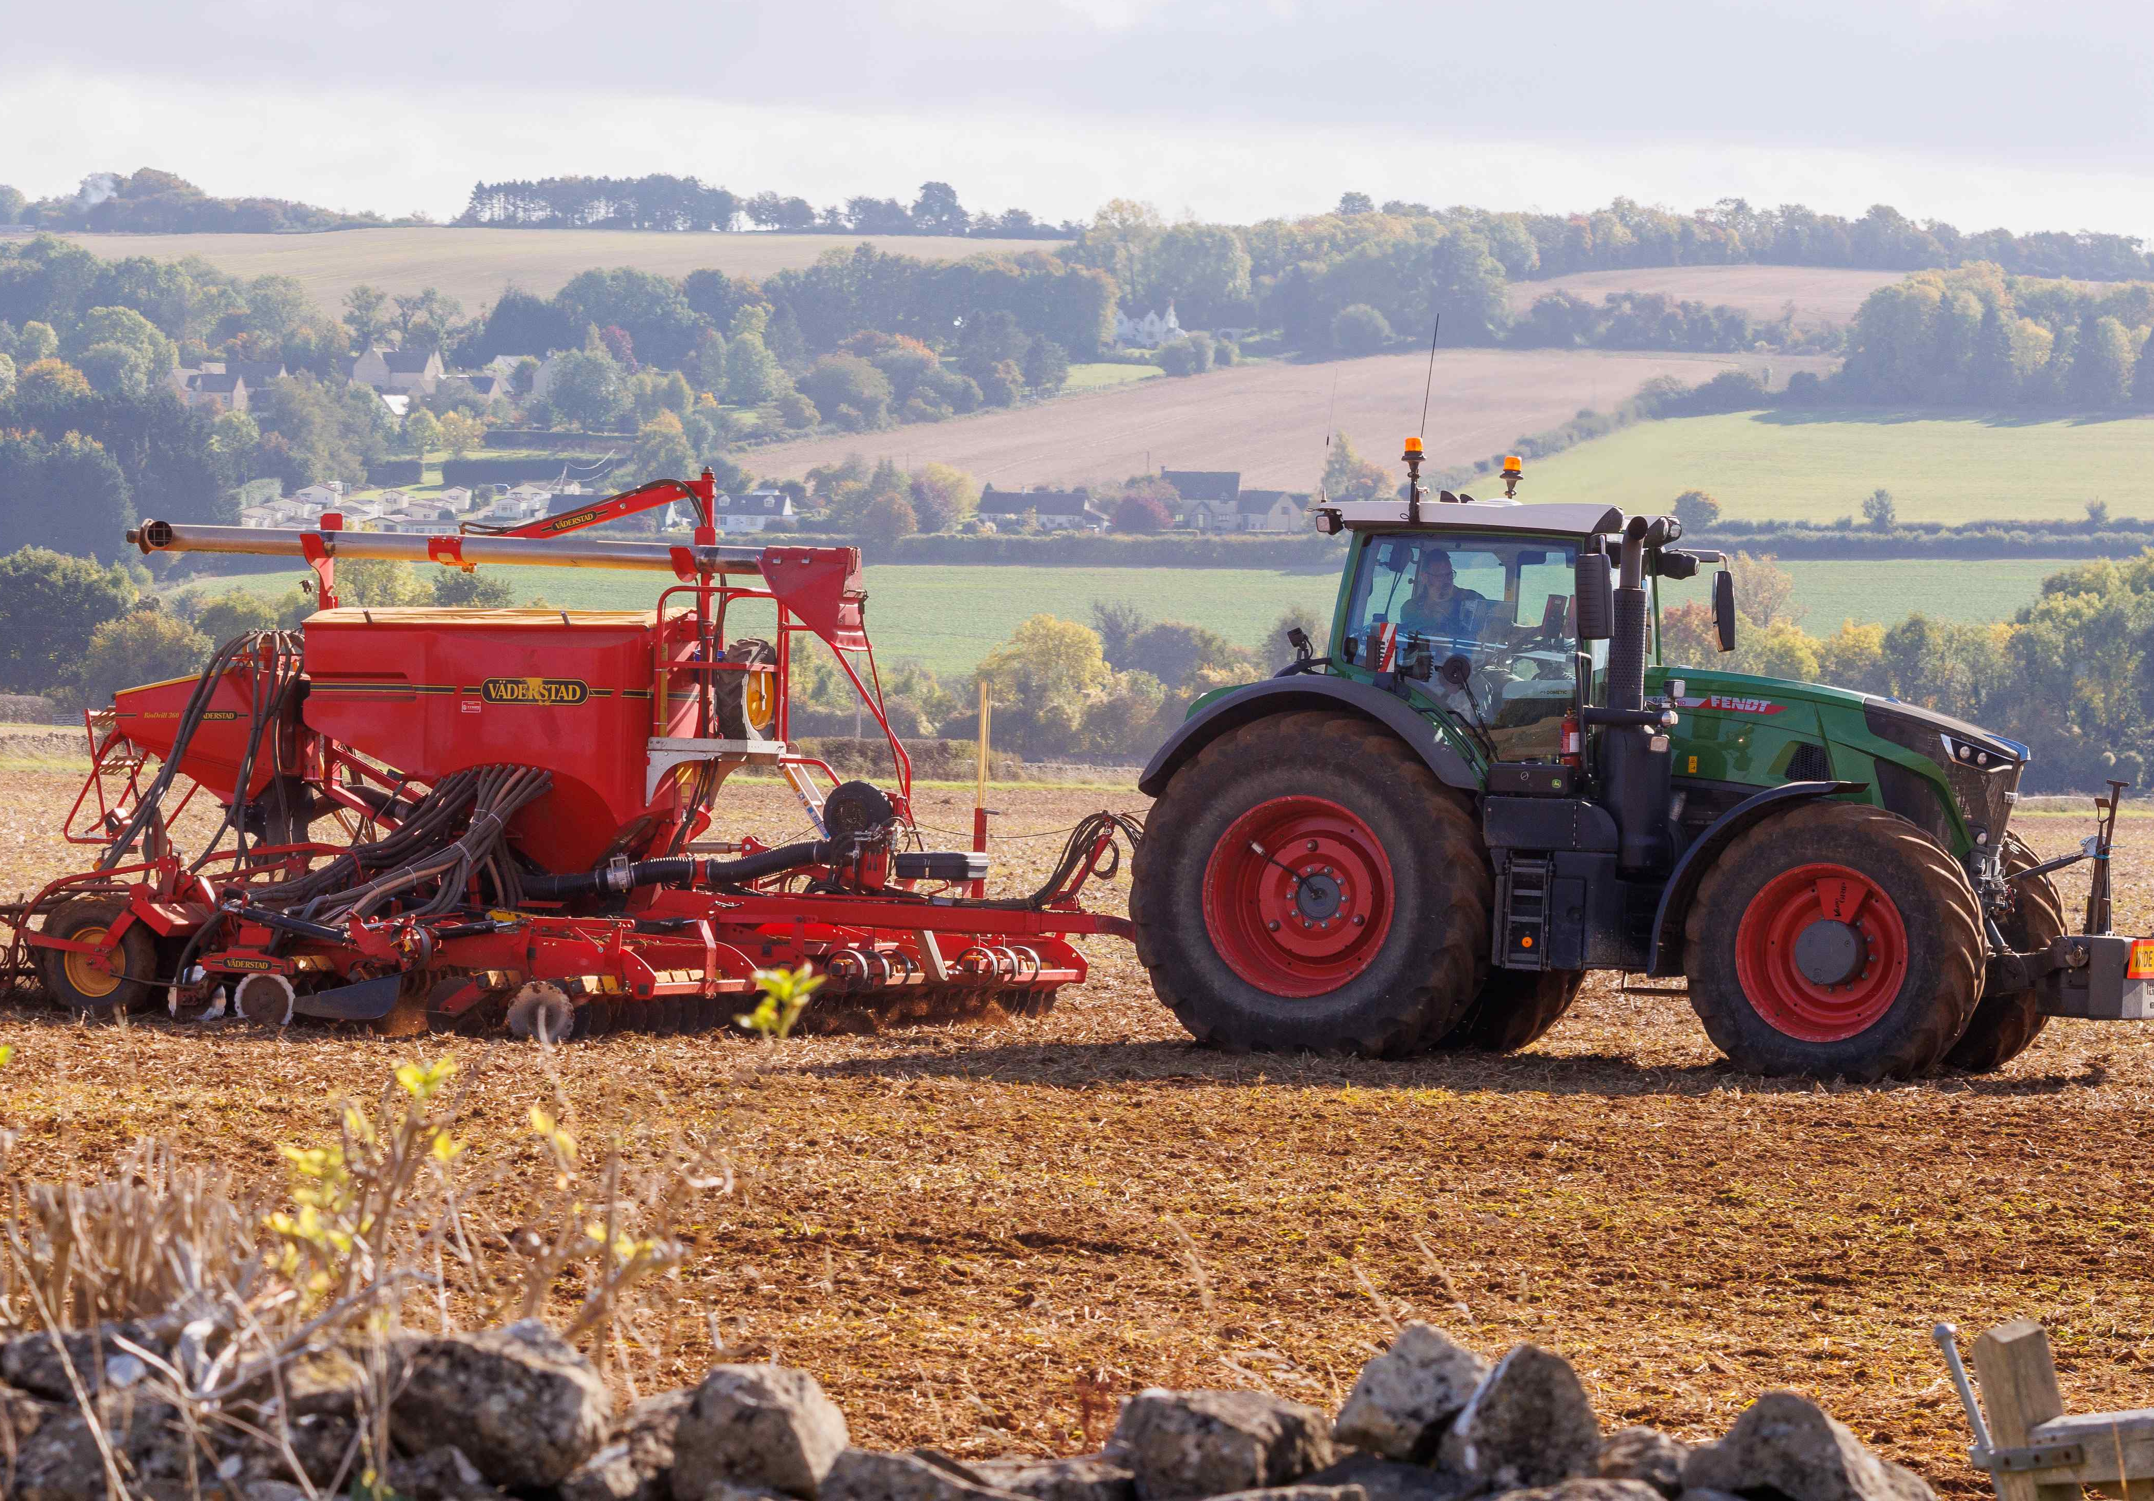
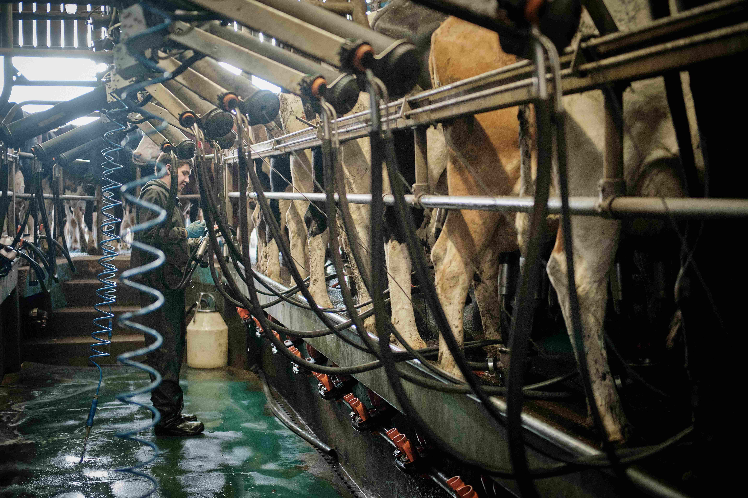
Trace over the words. Draw a line to match the right words to each picture.
Harvesting crops.
Milking cows.
Feeding cattle.
Planting crops.

