Bacon and mushroom risotto

Ingredients
Complexity: medium
150g risotto rice
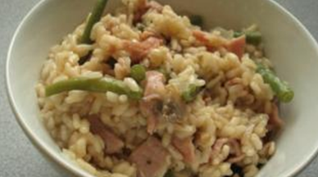
1 pork stock cube
600ml water
1 x 5ml spoon grated parmesan
Black pepper
1 onion
6 rashers lean sweet cure back bacon
50g mushrooms
100g green beans
1 x 5ml spoon oil

Equipment
Knife, chopping board, weighing scales, measuring spoon, mixing spoon, measuring jug, kettle.

Method
- Prepare the ingredients:
  - peel and chop the onion;
  - chop the bacon into large chunks;
  - slice the mushrooms;
  - chop the green beans in half.
- Heat the oil in a saucepan and fry the bacon and onion together.
- Add the mushrooms and green beans and fry for another 2 minutes.
- Stir in the rice.
- Make up the stock.
- Add the stock a little at a time, stirring constantly and allowing the rice to absorb the stock before adding any more liquid.
- Continue adding the stock until the rice is cooked – this will take 20-25 minutes. The rice should be soft, but still retain a nutty bite.
- Finally, stir in the parmesan cheese and a few twists of black pepper into the rice.

Top tips
- Sprinkle with parmesan cheese and top with rocket leaves to serve.
- Remember to keep adding liquid otherwise the rice will not cook, never let a risotto boil dry.

Food skills
- Weigh.
- Measure.
- Peel.
- Chop and slice.
- Fry.
- Stir.

